# Question 1: Use low pass filter for baseline restoration of EOG signal.

**Code:**

clc;

clear all;

close all;

load('LAB2EOG2-L10.mat');

Fs=1000;

L=length(data);

data=data(1:(L/3));

L=L/3;

t=(0:L-1)./Fs;

%% low pass filter

h=fdesign.lowpass('Fp,Fst,Ap,Ast',0.01,0.08,1,110);

d=design(h,'equiripple'); %Lowpass FIR filter

data_LPF=filtfilt(d.Numerator,1,data); %zero-phase filtering

subplot(2,1,1)

plot(t,data)

xlabel('Time(s)')

ylabel('Amplitude(mV)')

title('Original signal')

subplot(2,1,2)

plot(t,data_LPF)

xlabel('Time(s)')

ylabel('Amplitude(mV)')

title('Low pass Filter')

# Question 2: Find Alpha, beta, gamma, delta rhythms of EEG signal. (Find the asynchronous part)

Figure 2.1: Original EOG data and Output after Low pass filtering

Code:

clc; clear all;

load('Tamim_EEG_15-L03.mat')

x1=data;

subplot('511')

plot(x1);

title('Original EEG signal')

filtered_EEG= bandpass(x1,[8 13],200); %alpha

subplot('512')

plot(filtered_EEG);

title('Aplha rythm')

filtered_EEG= bandpass(x1,[13 30],200); %beta

subplot('513')

plot(filtered_EEG);

title('beta rythm')

filtered_EEG= bandpass(x1,[1 5],200); %gamma

subplot('514')

plot(filtered_EEG);

title('gamma rythm')

filtered_EEG= bandpass(x1,[4 8],200); %delta

subplot('515')

plot(filtered_EEG);

title('delta rythm')

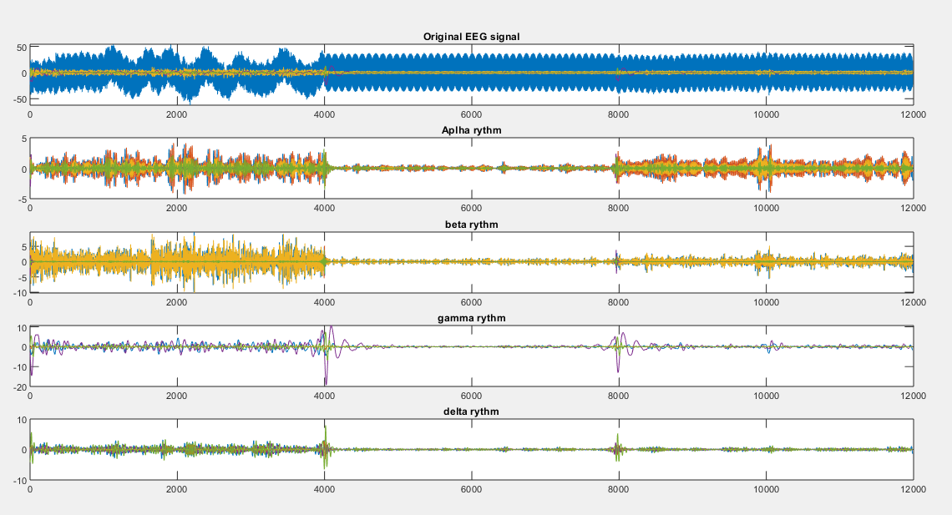

Figure 2.2: Original EEG data and Alpha, beta, gamma, and theta rhythms